Indian Chemical Council

Application Form
For
ICC - ADITYA BIRLA AWARD, 2008
for the Best Responsible Care Committed Company
&
Contest for “Best Compliant Company, for the Codes under Responsible Care®.”

Note: The Aditya Birla Award and citations for the performance under code/s are for composite company performance and not for any specific operating site.

For Aditya Birla Award the applicant company has to be a Responsible Care signatory and must have obtained ISO 14000 certification for all its sites (attach copies of certificates). However this rule is not applicable for those who are contesting for the code based competition

Please submit following for the Aditya Birla Award

A. Corporate Profile:

Please give data about the Company with specific reference to the following:

- Name and Status of Company viz. Private, Public Ltd., Joint Sector Company, Co-operative Sector etc.
- Year of Establishment.
- Capital & Financial Structure.
- Range of principal manufacturing activities/ engineering services.
- Location, Number of Employees & Organisation Structure.
- Annual reports for last three years out of which at least two must be audited (five sets only).

B. Reasons for being most eligible for the Aditya Birla Award or the citation under the code based contest:

Please provide briefly (in about 100 words for Aditya Birla Award and for other code related contest a paragraph on each) reasons for seeking this Award/citation, justifying and highlighting your significant contribution towards RC initiative in total or for the corresponding code/s.

C. For Aditya Birla Award furnish information on all Management Practices for following codes in the Item-wise check-list, given alongwith with this form to assess the compliance:

- Process Safety Code
- Employee Health and Safety Code
- Pollution Prevention Code
- Emergency Response Code
Also submit the information separately regarding compliance status for the Management Practices under Distribution and Product Stewardship Codes, as they would carry an extra weightage. Contesting company is expected to report the implementation status of all facilities separately and combined summary for all the sites.
ICC has published a “Guidance Manual on Responsible Care®”. Contesting companies are advised to procure the same from ICC National Headquarters at Mumbai or regional offices. Manual will help to know as to what exactly is expected under Management Practices under the Code.
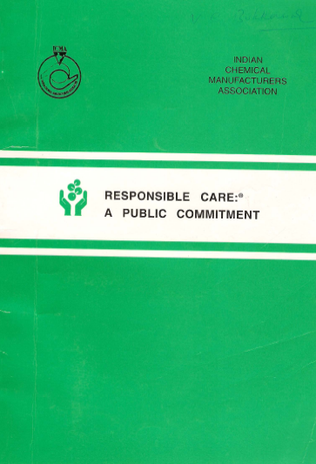
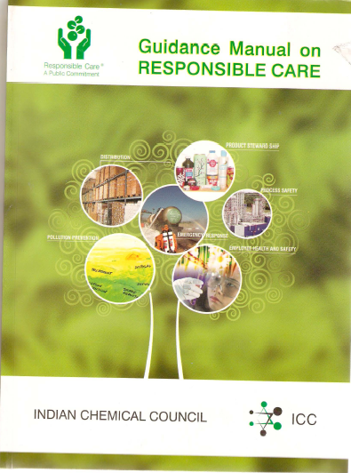

However the information pertaining to the status of compliance is to be submitted in the Table given in the booklet Responsible Care®, A Public Commitment published by ICC,. This form includes the same. You are expected to tick out in the one of the six categories viz.
- NA - No action ( However if marking NA please explain why NA is being marked)
- EV - Evaluating existing company practices against the Management Practice of
relevant Code
- DP – Developing Plan to implement Management Practice
- IA – Implementing action plan
- PP - Management Practice in place
- RI – reassessing Management Practice implementation

Wherever the compliance is shown in PP category, please explain in few lines about the compliance status, in comparison to the expectations indicated in the “Guidance Manual on Responsible Care®”, for each Management Practice. Same is also applicable for the compliance falling under RI category.

The information is to be submitted in “Hard and Soft”, later in CD

This is to facilitate the competing company as well as the “Scrutinizing Committee”.

  - Performance and other Information
Please submit all the above mentioned information in EIGHT copies, along with supporting literature, publications, such as Annual Report, Annual Report on SHE, Report on Responsible Care, G.R.I., News/House Magazines etc., related to SHE and sustainability issues. A separate Excel sheet is attached to this form for the Indices related data to be submitted.
For Code/s based Contest
Code-wise contest is open for all the codes given below
- Process Safety
- Employee Health & Safety
- Pollution Prevention
- Emergency Response
- Distribution
- Product Stewardship

Participant Company can apply for any single, multiple or all codes as per its own choice
The information to be submitted is to be exactly on the same lines as is explained for Aditya Birla Award earlier, however it is to be just focused for the code/s for which the company is participating in this contest.

Please indicate in the table below the contest for which your company is participating

Sr. No. | Contesting for | Participation status*
 | ICC - ADITYA BIRLA AWARD, 2008 for the Best Responsible Care Committed Company | Yes / No
 | Process Safety Code | Yes / No
 | Employee Health & Safety Code | Yes / No
 | Pollution Prevention Code | Yes / No
 | Emergency Response Code | Yes / No
 | Distribution Code | Yes / No
 | Product Stewardship Code | Yes / No

* Strike out whichever is not applicable

